



**Online Business Portal**

Individual Assignment

Panipat

CE00365-3-EWA

**Enterprise Web Applications**

**Date Assigned:** 2014

**Date Completed:** 15th April,2014

**Submitted By Submitted To**

Bhagyashri Bhaisare Mr. Ravi Sachdeva

(PT1082238) (Module Lecturer)





**CERTIFICATE**

This is to certify that Ms **Bhagyashri Bhaisare** of 8th semester pursuing B.Eng. (Hons) Degree from APIIT SD INDIA, Panipat has successfully completed the Individual assignment in **Enterprise Web Applications** module under the guidance of module lecturer Mr. Ravi Sachdeva within the specific time duration.

**-----------------------------**

**Bhagyashri Bhaisare**

Date:

**----------------------------------**

**Mr. Ravi Sachdeva**

**(Module Lecturer)**

# Acknowledgement

The developer takes feels privileged to acknowledge our assignment supervisor**, Mr Ravi Sachdeva**, for his timely guidance and tireless efforts that he provided to help gain a great learning experience. His source of inspiration and motivation resumed throughout the design, implementation and evaluation of the project. The topics of the lectures were extremely helpful in implementing the system and documenting the project.

Secondly, the developer appreciates the work of those (colleagues) who indirectly helped in suggesting valuable requirements and providing constructive criticism that benefited a lot in delivering the system. The vast internet resources provided much information regarding the assignment.

We gained a lot from the vast collection of books of APIIT library. It is the developer’s utmost pleasure to express warm thanks for the encouragement, co-operation and support of those whose name has not appeared here but should not go unnoticed for helping the developer to successfully complete the project.

Besides, the developer is grateful to the Almighty for keeping his grace during the whole development phase of the assignment.

BHAGYASHRI

Table of Contents

Acknowledgement 3

1.0. Introduction/Project Plan 5

**1.1.** **Background** 5

**1.2.** **Objectives** 5

**1.3.** **Scope** 5

**1.4.** **Targeted audiences** 5

**1.5.** **Project schedule** 6

**1.6.** **Summary of the major functions** 6

2.0. Requirement Specification 7

**2.1.** **Admin Module** 7

**2.2.** **Subscriber Module** 12

3.0. Design and Modeling 18

**3.2.** **Interface:** 20

**3.3.** **Architecture design** 31

**3.4.** **Design Decisions** 31

4.0. Implementation 34

5.0. Conclusion 36

**5.1.** **Summary** 36

**5.2.** **Future works** 36

6.0. References 37

7.0. Appendices 38

# Introduction/Project Plan

* 1. **Background**

Sell & Purchase Pre-owned Vehicles (SPPV) started their business their native place, Panipat. The business setup comprised of an office where people those who have to sell their vehicles used to come and register their contact details so that if any customer comes to purchase a pre-owned vehicle the company can give the vehicle details. The company charges both side parties for this process with some reasonable amount.

The company owner Mr. Nene observed that they are not able to reach out to as many customers which lead to find him some means of advertisement for his business. So in order to extend his business, he desired to make an online commercial website for the customers throughout the India. With this goal in mind, he approached the developer (ASP.NET) to achieve his goal. The company owner was told the benefits of making commercial website and what functionalities can be given to the customers. So that the process of selling and purchasing of used vehicles will be user-friendly and convenient to search for used vehicles sitting at their own place.

* 1. **Objectives**

The main objectives of the system are as follows:

* To sell and purchase vehicle.
* To generate business.
* To ensure that data entered by the subscribers should not be garbage that is only meaningful information should be uploaded by the subscribers.
* To ensure that only used vehicles are uploaded in the add vehicles section.
* To expand the business throughout the country.
* To reach the maximum number of customer.
  1. **Scope**
* The system can be operational in India only
* The system is basically for the used vehicles.
* Language supported by the system is English only.
  1. **Targeted audiences**

The audience comprises of all those users who want to either sell their vehicle or purchase the pre-owned vehicle.

* 1. **Project schedule**

Refer to Appendices for Gantt Chart.

* 1. **Summary of the major functions**

The function of the system to be developed is classified on the basis of four types of users like Admin, Paid Subscriber, Free Subscriber and Visitor or Anonymous user. The functions of the system to be developed are summarized with the help of table as given below:

* + 1. **Functions of Admin:**

|  |  |
| --- | --- |
| Function | Description |
| Add new Subscriber: | Administrator can add new subscribers by registering with the personal details of the subscribers. |
| Add Vehicle: | Administrator can upload vehicle in the account of the respective subscriber. |
| Delete Subscriber: | Administrator can delete subscriber. |
| Delete Vehicle: | Administrator can delete subscriber. |
| Approve/Reject Vehicle: | Administrator will approve the vehicle details and then only vehicle will be displayed during search vehicles. |
| Change Status: | Administrator will give the status of registered subscribers as ‘Free’ or ‘Paid’ on the basis of payment details for subscription. |
| View all Subscribers: | Admin can view the details of all subscribers, Paid as well as Free. |
| Send Message to Subscriber | Admin can send message regarding payment details or vehicle details to subscribers either Paid or Free. |

* + 1. **Functions of Paid Subscriber:**

|  |  |
| --- | --- |
| Function | Description |
| Login | Paid Subscriber can login to their account to manage their account and to search used vehicle details or upload vehicle details. |
| Search Vehicles Details | Paid Subscriber can search vehicle based on different criteria. |
| Add Vehicle | Paid Subscriber can upload vehicle details with vehicle image to sell. |
| View Seller Information | After a vehicle is searched, paid subscriber can view the contact details of the seller. |
| Check Message | Paid Subscriber can view messages sent by Admin. |

* + 1. **Functions of Free Subscriber:**

|  |  |
| --- | --- |
| Function | Description |
| Login | Free Subscriber can login to their account to manage their account and to search used vehicle details for purchasing or upload vehicle details to sell. |
| Search Vehicles Details | Paid Subscriber can search vehicle based on different criteria. |
| Add Vehicle | Paid Subscriber can upload vehicle details with vehicle image to sell. |
| Send Request to Become Paid Subscriber | Free Subscribers can send request to Admin to become Paid Subscriber. |
| Check Message | Paid Subscriber can view messages sent by Admin. |

* + 1. **Functions of Visitor or Anonymous user:**

|  |  |
| --- | --- |
| Function | Description |
| Register | Visitor can register themselves as subscriber of the portal. |
| Give Feedback | Visitors are provided feedback form give their comments and suggestions. |

# Requirement Specification

* 1. **Admin Module**
     1. **Add New Subscriber form (AddNewSubscriber.aspx)**: Admin will add new subscriber with the help of this form. Information Required is as follows:

|  |  |  |  |  |
| --- | --- | --- | --- | --- |
| Fields | Mandatory/Optional | Input Type | Constraints/ validation | Purpose /description |
| Username | Mandatory | Text-based | * Field cannot be empty * Username should be at least 5 characters long * Username can contain characters from a-z, A-Z, 0-9 or _ (underscore) | Required to uniquely identify a subscriber within the system |
| Password | Mandatory | Text-based | * Field cannot be empty * Password should be at least 6 characters long * Password can contain characters from a-z, A-Z, 0-9 and special characters | Required for secure access of subscribers to login into their account |
| Retype Password | Mandatory | Text-based | * Field cannot be empty * Characters should match with previous password field | Required to confirm the password that is typed in previous field. |
| Name | Mandatory | Text-based | * Field cannot be empty. * Should be at least 5 characters long * Should contain characters from a-z or A-Z. | Required for identification purpose |
| Mobile Number | Mandatory | Text-based | * Field cannot be empty. * Should be 10 digits long. * Only digits are allowed. * First digit should be 7, 8 or 9. | Required so that customer or admin can contact the subscriber |
| Email | Mandatory | Text-based | * Field cannot be empty. * Should follow email address format.(ex. User22@domain.com) | Required so that customer or admin can contact the subscriber via email. |
| State | Mandatory | Selection-based | * Must select a state from the given list of states. | Required to know the state from where subscriber belongs |
| City | Mandatory | Selection-based | * Must select a city from the given list of cities. | Required to know the city of the subscriber |
| Address | Mandatory | Selection-based | * Field cannot be empty. * Must be at least 10 characters long and can be from a-z, A-Z or 09. | Required to know the exact address to contact the subscriber |
| Submit |  |  |  | To submit the filled subscriber details. |

* + 1. **Add Vehicle Details form (Admin_AddVehicle.aspx)**: Admin can add the vehicle details in the account of an existing subscriber either of “Paid” or “Free”.

|  |  |  |  |  |
| --- | --- | --- | --- | --- |
| Fields | Mandatory/Optional | Input Type | Constraint/ validation | Purpose /description |
| Category | Mandatory | Selection-based | * Must select one of the categories listed | Required to identify category of vehicle |
| Brand Name | Mandatory | Selection –based | * Must select one of the categories listed | Required to identify Brand of vehicle |
| Condition | Mandatory | Selection-based | * Must select one of the conditions listed | Required to identify how the condition of vehicle is. |
| Year | Mandatory | Text-based | * Must select one of the years listed | Required for identification purpose |
| KMs Driven | Mandatory | Text-based | * Field cannot be empty. * Should be 10 digits long. * Only digits are allowed. * First digit should be 7, 8 or 9. | Required so that customer or admin can contact the subscriber |
| Price | Mandatory | Text-based | * Field cannot be empty. * Should follow email address format.(ex. User22@domain.com) | Required so that customer or admin can contact the subscriber via email. |
| Photos | Mandatory | Selection-based | * Must select a state from the given list of states. | Required to know the state from where subscriber belongs |

* + 1. **Send Message form (SendMessage.aspx):** Admin can send message to the subscribers either “Paid” or “Free” if there is any suggestion to be given to the subscriber or contact him regarding any of the account relevant issues.

|  |  |  |  |  |
| --- | --- | --- | --- | --- |
| Controls | Mandatory/Optional | Input Type | Constraint/ validation | Purpose /description |
| Grid View | Mandatory | Grid-based |  | Shows the list of subscribers |
| Drop Down List |  |  |  | To select type of subscriber either paid, free or all. |

* 1. **Subscriber Module**
     1. **Free Subscriber Login form (FreeLogin.aspx):** This form is designed so that free subscribers can login to their respective account.

|  |  |  |  |  |
| --- | --- | --- | --- | --- |
| Fields | Mandatory/Optional | Input Type | Constraint/ validation | Purpose /description |
| Username | Mandatory | Text-based | * Field cannot be empty * Username should be at least 5 characters long * Username can contain characters from a-z, A-Z, 0-9 or _ (underscore) | Required to login to their respective account |
| Password | Mandatory | Text-based | * Field cannot be empty * Password should be at least 6 characters long * Password can contain characters from a-z, A-Z, 0-9 and special characters | Required to login to their respective account |

* + 1. **Paid Subscriber Login form (PaidLogin.aspx):** This form is designed so that paid subscribers can login to their respective account.

|  |  |  |  |  |
| --- | --- | --- | --- | --- |
| Fields | Mandatory/Optional | Input Type | Constraint/ validation | Purpose /description |
| Username | Mandatory | Text-based | * Field cannot be empty * Username should be at least 5 characters long * Username can contain characters from a-z, A-Z, 0-9 or _ (underscore) | Required to login to their respective account |
| Password | Mandatory | Text-based | * Field cannot be empty * Password should be at least 6 characters long * Password can contain characters from a-z, A-Z, 0-9 and special characters. | Required to login to their respective account |

* + 1. **Add Vehicle form (AddVehicle.aspx):** This form is designed so that subscribers can add their vehicle details for the purpose of selling.

|  |  |  |  |  |
| --- | --- | --- | --- | --- |
| Fields | Mandatory/Optional | Input Type | Constraint/ validation | Purpose /description |
| Category | Mandatory | Selection-based | * Must select one of the categories listed | Required to identify category of vehicle |
| Brand Name | Mandatory | Selection –based | * Must select one of the categories listed | Required to identify Brand of vehicle |
| Condition | Mandatory | Selection-based | * Must select one of the conditions listed | Required to identify how the condition of vehicle is. |
| Year | Mandatory | Text-based | * Must select one of the years listed | Required for identification purpose |
| KMs Driven | Mandatory | Text-based | * Field cannot be empty. * Should be 10 digits long. * Only digits are allowed. * First digit should be 7, 8 or 9. | Required so that customer or admin can contact the subscriber |
| Price | Mandatory | Text-based | * Field cannot be empty. * Should follow email address format.(ex. User22@domain.com) | Required so that customer or admin can contact the subscriber via email. |
| Photos | Mandatory | Selection-based | * Must select a state from the given list of states. | Required to know the state from where subscriber belongs |

* + 1. **Send Request to Admin for being Paid Subscriber form (SendRequest.aspx):** This form contains the payment details required to be filled in by the Free Subscriber and sent to Admin to become paid subscriber.

|  |  |  |  |  |
| --- | --- | --- | --- | --- |
| Fields | Mandatory/Optional | Input Type | Constraint/ validation | Purpose /description |
| Payment Mode | Mandatory | Selection-based | * Field cannot be empty * Username should be at least 5 characters long * Username can contain characters from a-z, A-Z, 0-9 or _ (underscore) | Required to login to their respective account |
| Cheque No/DD No | Mandatory | Text-based | * Field cannot be empty * Password should be at least 6 characters long * Password can contain characters from a-z, A-Z, 0-9 and special characters | Required to login to their respective account |
| Subscription Amount |  | Selection-based | * Must select an amount out the given amounts | Required to know the subscription amount paid by subscriber |

* 1. **Registration form (Registration.aspx):** This form is used to do the registration of the visitors to become the member of online web portal.

|  |  |  |  |  |
| --- | --- | --- | --- | --- |
| Fields | Mandatory/  Optional | Input Type | Constraints/ validation | Purpose /description |
| Username | Mandatory | Text-based | * Field cannot be empty * Username should be at least 5 characters long * Username can contain characters from a-z, A-Z, 0-9 or _ (underscore) | Required to uniquely identify a subscriber within the system |
| Password | Mandatory | Text-based | * Field cannot be empty * Password should be at least 6 characters long * Password can contain characters from a-z, A-Z, 0-9 and special characters | Required for secure access of subscribers to login into their account |
| Retype Password | Mandatory | Text-based | * Field cannot be empty * Characters should match with previous password field | Required to confirm the password that is typed in previous field. |
| Name | Mandatory | Text-based | * Field cannot be empty. * Should be at least 5 characters long * Should contain characters from a-z or A-Z. | Required for identification purpose |
| Mobile Number | Mandatory | Text-based | * Field cannot be empty. * Should be 10 digits long. * Only digits are allowed. * First digit should be 7, 8 or 9. | Required so that customer or admin can contact the subscriber |
| Email | Mandatory | Text-based | * Field cannot be empty. * Should follow email address format.(ex. User22@domain.com) | Required so that customer or admin can contact the subscriber via email. |
| State | Mandatory | Selection-based | * Must select a state from the given list of states. | Required to know the state from where subscriber belongs |
| City | Mandatory | Selection-based | * Must select a city from the given list of cities. | Required to know the city of the subscriber |
| Address | Mandatory | Selection-based | * Field cannot be empty. * Must be at least 10 characters long and can be from a-z, A-Z or 09. | Required to know the exact address to contact the subscriber |

* 1. **Visitor Feedback Form (Feedback.aspx):** This form is used by the visitor or anonymous user to give the feedback regarding the Sell and Purchase of Pre-owned vehicles.

|  |  |  |  |  |
| --- | --- | --- | --- | --- |
| Fields | Mandatory/Optional | Input Type | Constraint/ validation | Purpose /description |
| Email Address | Mandatory | Text-based | * Field cannot be empty * Username should be at least 5 characters long * Username can contain characters from a-z, A-Z, 0-9 or _ (underscore) | Email address of the visitor giving feedback is required. |
| Feedback | Mandatory | Text-based | * Field cannot be empty * Password should be at least 6 characters long * Password can contain characters from a-z, A-Z, 0-9 and special characters. | The feedback given by the visitor. |

# Design and Modeling

* 1. **Database Design**

**Table 1: tb_Register**

**Description:** This table is used to store information about all the subscribers either paid or free with all their personal details.

|  |  |  |  |
| --- | --- | --- | --- |
| Field | Data type | Null | Field Description/constraint |
| Username | varchar(50) | Not Null | Primary Key  Stores username of the subscriber that is used to login to their account |
| Password | varchar(50) | Not Null | Stores password of the subscribers to maintain security and privacy of their data |
| Name | varchar(50) | Not Null | Stores the name of subscriber |
| MobileNo | Int | Not Null | Stores mobile number of the subscriber |
| Email | varchar(50) | Not Null | Stores email address of the subscriber to contact |
| State | varchar(50) | Not Null | Stores the state to which subscriber belongs |
| City | varchar(50) | Not Null | Stores the city to which subscriber belongs |
| Address | varchar(50) | Not Null | Stores the address where subscriber lives presently |
| Subscription | varchar(50) | Not Null | Stores the subscription status of the subscriber |

**Table 2: tb_Admin**

**Description:** This tables stores the username and password of the Admin to login to his account to manage the system.

|  |  |  |  |
| --- | --- | --- | --- |
| Field | Data type | Null | Field Description/constraint |
| a_username | varchar(10) | Not Null | Stores username of the Admin |
| a_password | varchar(10) | Not Null | Stores password of the Admin |

**Table 3: tb_Vehicle**

**Description:** This table stores the details of the used vehicle to be sold which are uploaded by free or paid subscribers or admin.

|  |  |  |  |
| --- | --- | --- | --- |
| Field | Data type | Null | Field Description/constraint |
| Vehicle_id | Int | Not Null | Unique Key (Identity column)  Maintains a unique id for each vehicle added. |
| Username | varchar(50) | Not Null | Foreign Key  Stores the username of the subscriber who has uploaded the vehicle |
| Category | varchar(50) | Not Null | Stores the category of uploaded vehicle |
| V_image | Image | Not Null | Stores the image of uploaded vehicle |
| Brand | varchar(50) | Not Null | Stores the brand of uploaded vehicle |
| Year | varchar(50) | Not Null | Stores the purchasing year of uploaded vehicle |
| Distance | varchar(50) | Not Null | Stores the distance travelled by uploaded vehicle in kilometers. |
| Condition | varchar(50) | Not Null | Stores the condition of uploaded vehicle |
| Price | varchar(50) | Not Null | Stores the price of uploaded vehicle |
| Status | varchar(50) | Not Null | Stores the status of uploaded vehicle whether it is approved, rejected or pending. |

**Table 4: tb_SubscriptionDetails**

**Description:** This table contains the data regarding the payment details of subscription by the free subscribers to become paid subscriber.

|  |  |  |  |
| --- | --- | --- | --- |
| Field | Data type | Null | Field Description/constraint |
| Username | varchar(50) | Not Null | Foreign Key  Stores the username of the subscriber who has sent payment for paid subscription |
| paymentMode | varchar(50) | Not Null | Stores payment mode either DD or cheque |
| Chqddno | varchar(50) | Not Null | Stores the cheque no. or DD no. |
| Date | varchar(50) | Not Null | Stores the date of dd or cheque. |
| sAmount | varchar(50) | Not Null | Stores the subscription amount to be paid |
| Status | varchar(50) | Not Null | Stores the status of subscriber whether it is Paid, Free or Pending. |

**Table 5: tb_ MessageHistory**

**Description:** This table stores the details of messages sent by Admin to the subscribers either free or paid.

|  |  |  |  |
| --- | --- | --- | --- |
| Field | Data type | Null | Field Description/constraint |
| Message_no | Int | Not Null | Unique Key (Identity Column)  Assigns unique no. to every message |
| Username | varchar(50) | Not Null | Foreign Key  Stores the username of the subscriber to whom the message is sent |
| Subject | varchar(50) | Not Null | Stores the subject of message |
| Message | varchar(50) | Not Null | Stores the message content |
| Date | Datetime | Not Null | Store the date and time of the sent message. |

**Table 6: tb_Feedback**

**Description:** This table stores the details of Feedback given by visitor of the portal.

|  |  |  |  |
| --- | --- | --- | --- |
| Field | Data type | Null | Field Description/constraint |
| Fd_id | Int |  | Unique Key (Identity column)  Assigns an id to every feedback |
| Email_id | varchar(50) | Not Null | Stores email id of the visitor who gives feedback |
| Feedback | varchar(150) | Not Null | Feedback content |
| Timing | Datetime | Not Null | Stores the date and time when the feedback was given |

* 1. **Interface Designs:**

The Interface Design consists of Screenshots of the Online Web Portal of Sell and Purchase of Pre-Owned Vehicle and their description are as follows:

**Screenshots of Admin Part:**

1. **WelcomePage.aspx:**

**Description:** This web page is the welcome page for this online web portal which provides links to various other web pages within the portal such as member login either free or paid, registration and feedback for visitors.

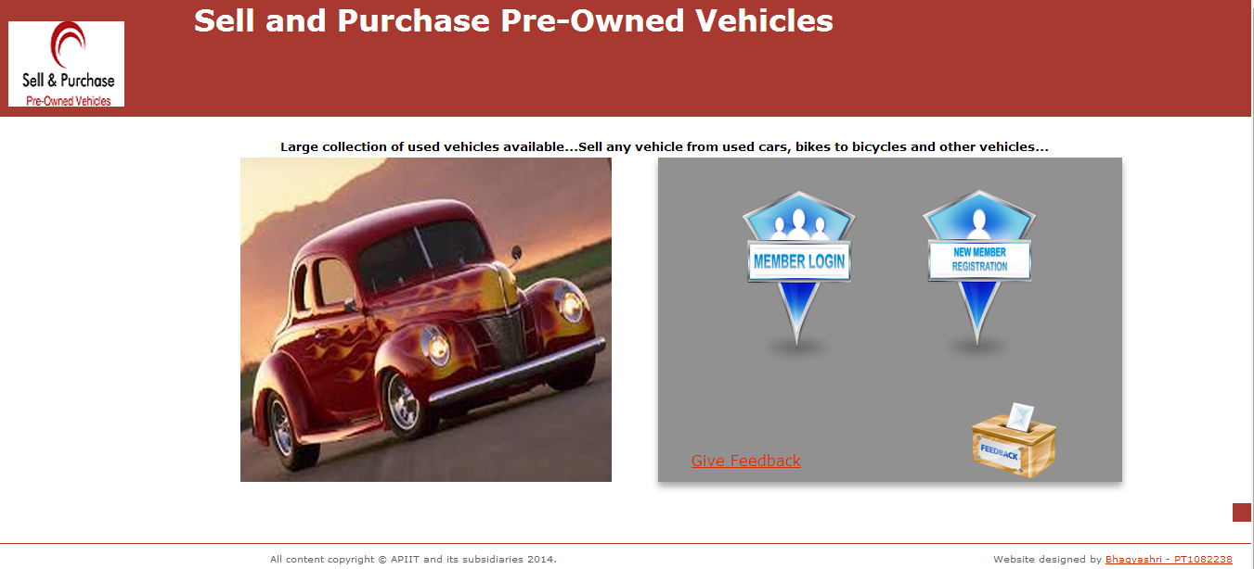

Figure Welcome page of Online web portal

1. **Login.aspx:**

**Description:** This web page provides login interface for the Admin to login to their respective account. The web page asks the user to enter his or her username and password and if the entered username and password matches with database values for the admin table values then user is logged in.

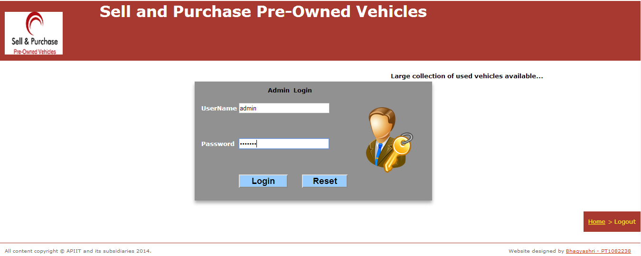

Figure Admin Login

1. **Admin.aspx:**

**Description:** This is the home page of Admin of Sell and Purchase Pre-owned Vehicle. This page has several links to perform different Admin functionalities like add new subscriber, delete subscriber, etc.

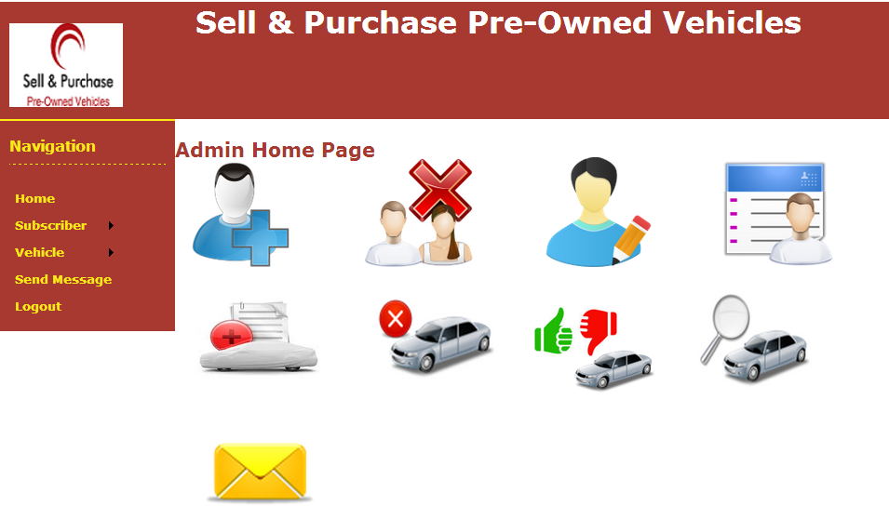

Figure 3 Admin Home Page

1. **AddNewSubscriber.aspx:**

**Description:** This web form is used to add new subscriber by the Administrator. There are fields in this form that requires the personal details of the user who is being added by the Admin.

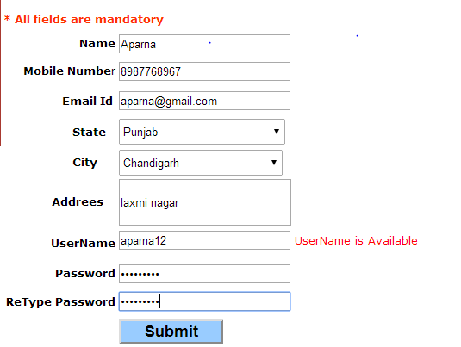

Figure Admin - Add Subscriber

1. **Admin_AddVehicle.aspx:**

**Description:** The used vehicle that is to be sold is uploaded with the help of this form including its details like category, brand, condition, etc. The vehicle is added by the Admin in the account of respective subscriber.

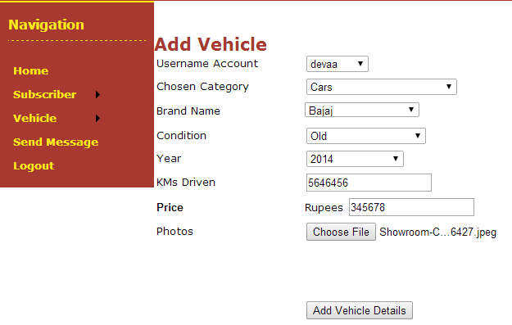

Figure Admin - Add Vehicle

1. **Admin_SearchVehicle.aspx:**

**Description:** With the help of this web page of the system, Admin can search the vehicle along with the details of the seller that has added the vehicle. First screenshot shows all the vehicles available and second screenshot shows vehicles from city ‘Ambala’.

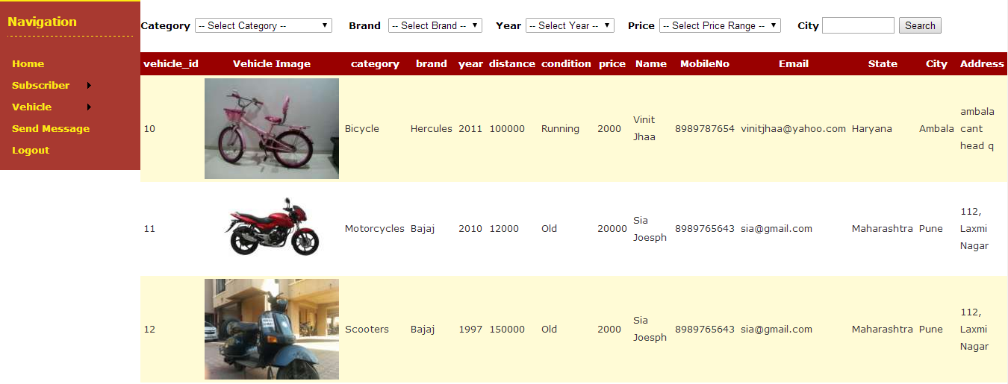

Figure Admin - Search Vehicle

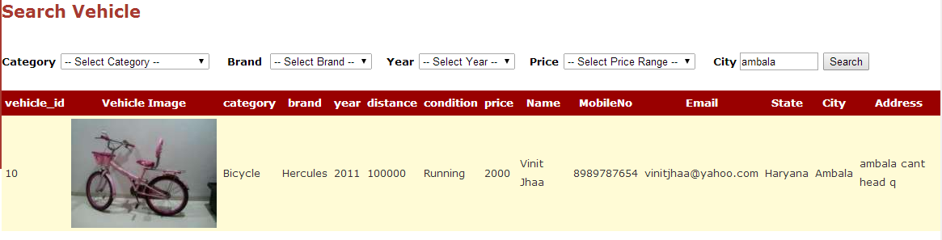

Figure Admin - Search Vehicle with Criteria of City given

1. **SetMemberStatus.aspx:**

**Description:** Admin sets the status of subscriber as Free or Paid after checking the payment details for the subscription.

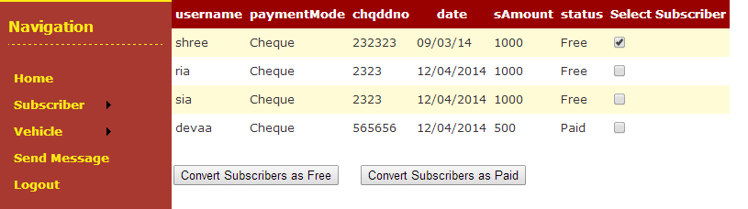

Figure Admin - Changing status of Free (shree) to Paid

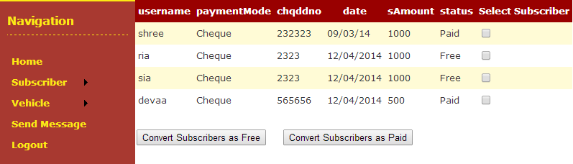

Figure Admin - Status changed to Paid

1. **ArVehicle.aspx:**

**Description:** The uploaded vehicle is Approved or Rejected by the Admin with the help of this form. Once the vehicle is approved by the Admin then only it will be displayed when vehicle search is performed by the subscriber.

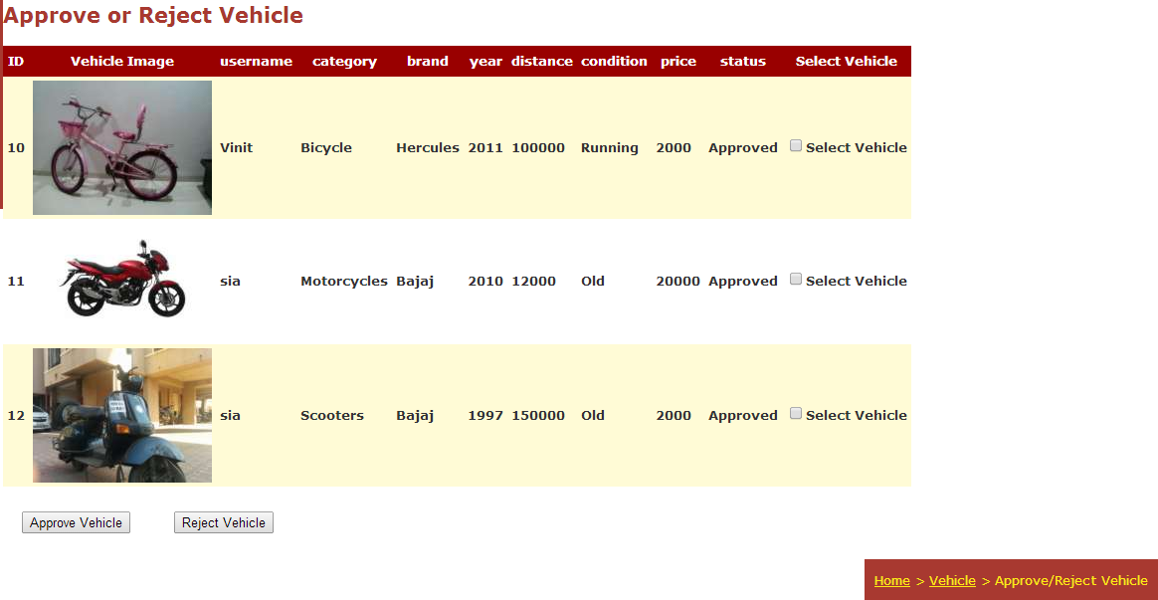

Figure Admin - Approve / Reject Vehicle

1. **DeleteSubscriber.aspx:**

**Description:** This page is used by the Admin to delete subscriber. The details of the subscriber including paid and free are displayed first in grid view and then a Delete button is clicked to delete the subscriber.

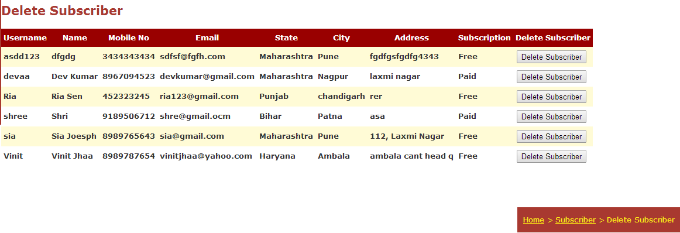

Figure Admin - Delete Subscriber

1. **DeleteVehicle.aspx:**

**Description:** This page is used by the Admin to delete uploaded vehicle. The details of the subscriber including paid and free are displayed first in grid view and check box list is provided to select one or more vehicle at the same time and then deleted.

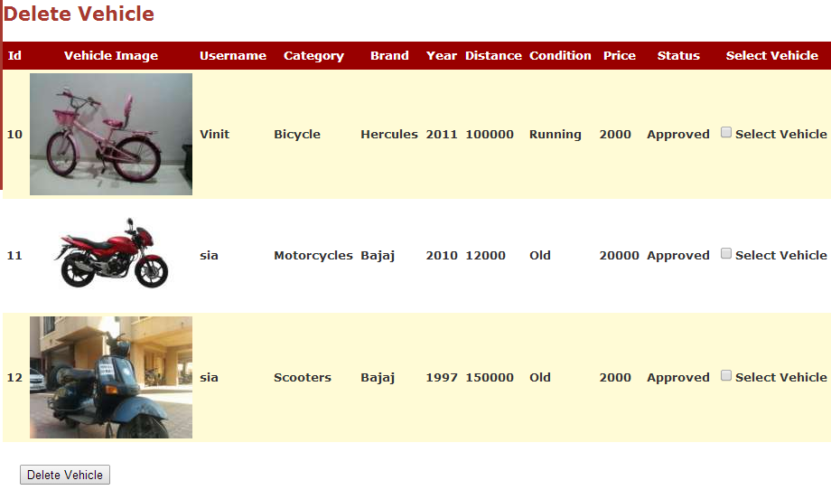

Figure 12 Admin- Delete Vehicle

1. **ViewSubscribers.aspx:**

**Description:** Admin uses this webpage that displays all the registered subscribers free as well as paid with the help of Grid View and Drop down list.

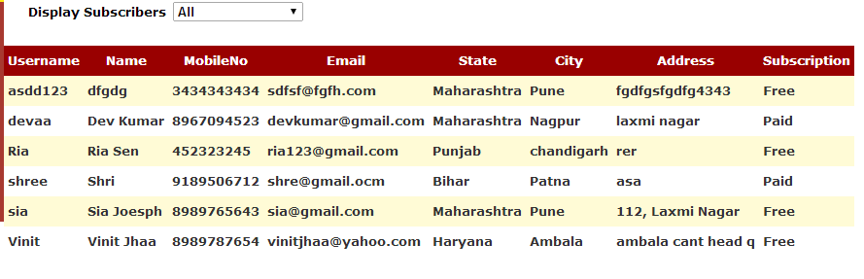

Figure Admin - Displaying All Subscribers

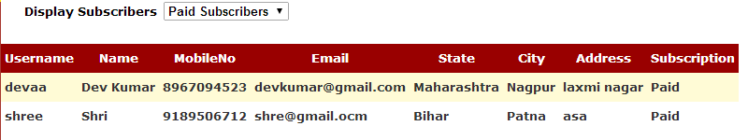

Figure Admin - Displaying Only Paid Subscribers

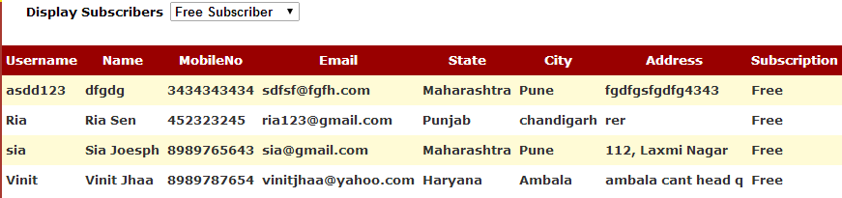

Figure Admin - Displaying only Free Subscribers

1. **SendMessage.aspx:**

**Description:** This webpage is used by the Admin to send messages to one or multiple subscriber at a same time. In this Admin selects the subscribers, enters subject of message and then the message and sends it to the subscriber.

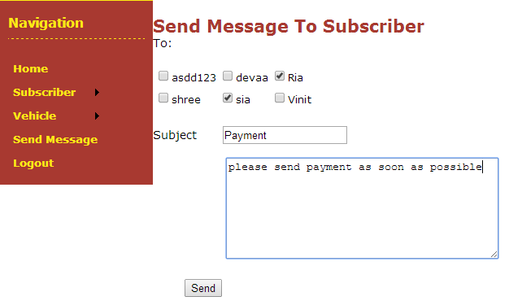

Figure Admin sending message to selected subscribers

**Screenshots of User Part (Subscriber and Visitor):**

1. **FreeLogin.aspx:**

**Description:** This web page provides login interface for the free subscriber to login to their respective account. The web page asks the user to enter his or her username and password and if the entered username and password matches with database values for the status free then user is logged in.

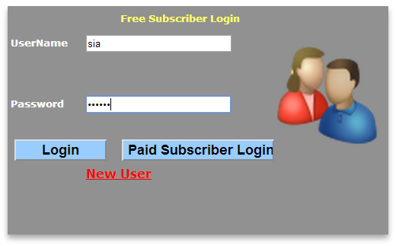

Figure Free Subscriber login

1. **AddVehicle.aspx:**

**Description:** The used vehicle that is to be sold is uploaded with the help of this form including its details like category, brand, condition, etc. The vehicle is added by the subscriber who wants to sell his or her vehicle.

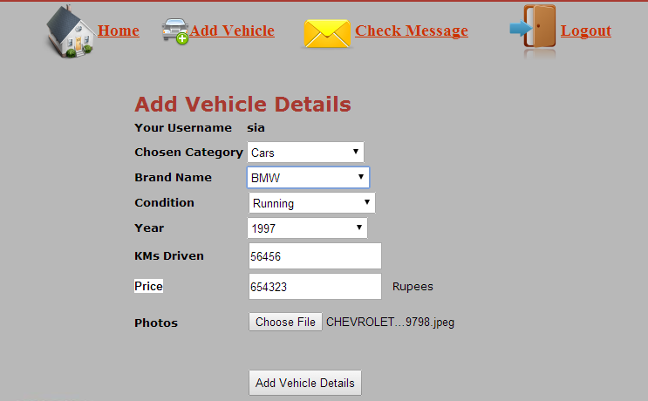

Figure Subscriber Adding Vehicle Details

1. **SubscriberHomePage.aspx:**

**Description:** This web page is the home page of subscriber once he is logged in to his account. With the help of this page, subscriber can search for used vehicle to purchase or he can upload vehicle details to sell it. Subscribers can check the messages sent by the system AdminFree subscriber can send request to become paid.

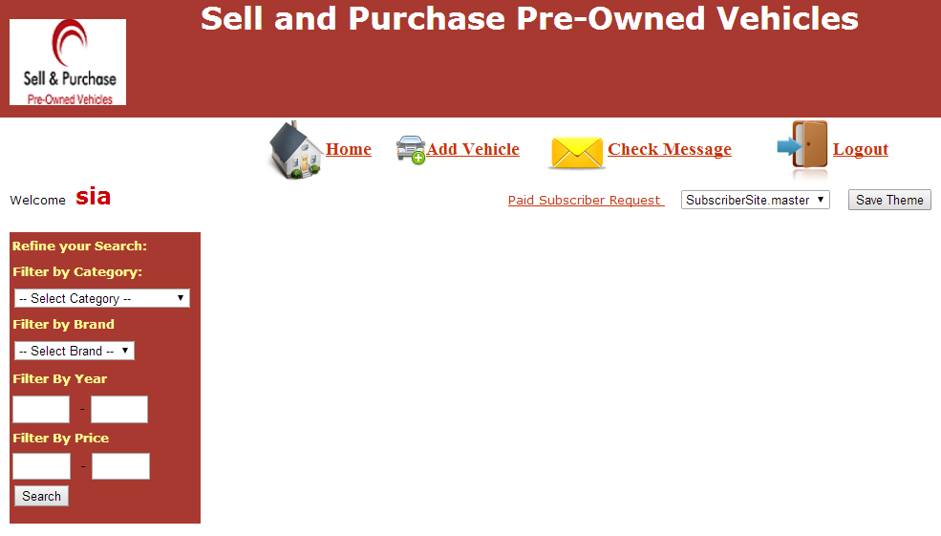

Figure Subscriber Home Page with relevant links

1. **PaidLogin.aspx:**

**Description:** This web page provides login interface for the subscriber to login to their respective account. The web page asks the user to enter his or her username and password and if the entered username and password matches with database values for the paid subscriber values then user is logged in.

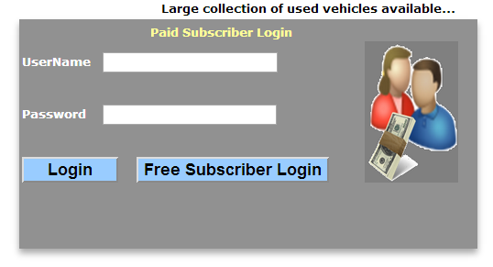

Figure Paid Subscriber Login

1. **Registration.aspx:**

**Description:** This webpage is used by the visitor to register himself as a subscriber of online web portal wherein he has to enter his personal information and submit the form.

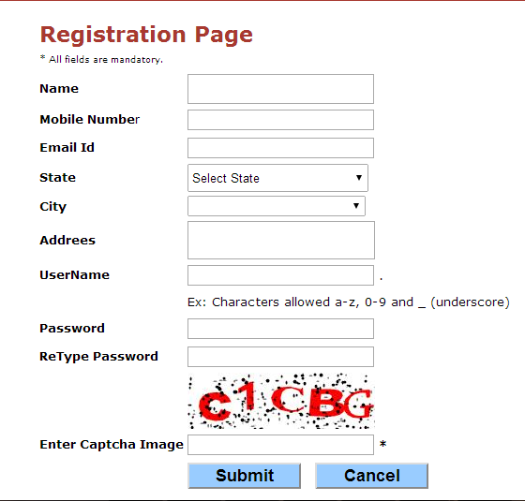

Figure Registration Page for Visitors to subscribe

1. **SendRequest.aspx:**

**Description:** This webpage is used by the Free Subscriber to send request to Admin for being paid subscriber. The subscriber enters the payment details how he is going to pay the subscription amount and then sends the request by clicking Send Request Button.

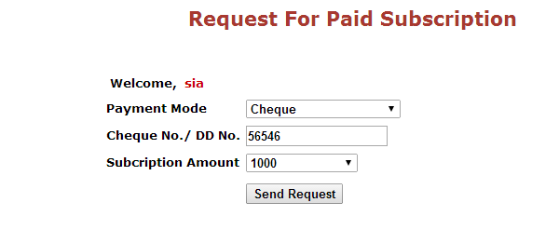

Figure Payment details filled by free subscriber

1. **PaidSubscriberHomePage.aspx:**

**Description:** This webpage is the home page of the paid subscriber wherein he can search for the vehicles to purchase based on several criteria. Other links are for adding a vehicle to sell and check inbox and logout.

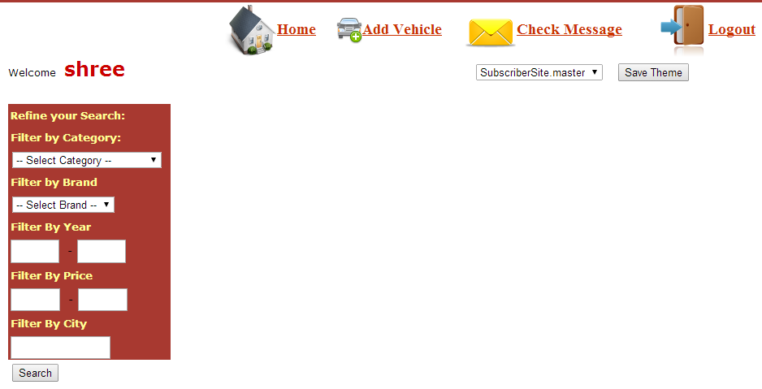

Figure Paid Subscriber Home Page without Send Request (for being paid) link

1. **SubscriberInbox.aspx:**

**Description:** This webpage displays the messages sent to the subscriber by the Admin in a grid view.

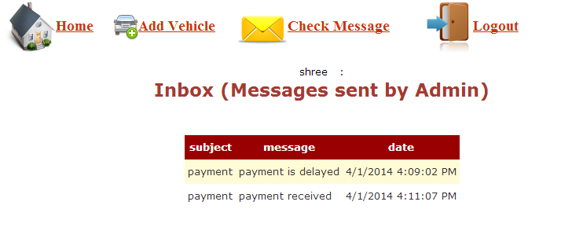

Figure Displaying messages sent to subscriber by Admin

1. **Feedback.aspx:**

**Description:** This form is used by the Visitor to give feedback regarding this online web portal. The email id and feedback that is to be given is entered in this form and then submitted.

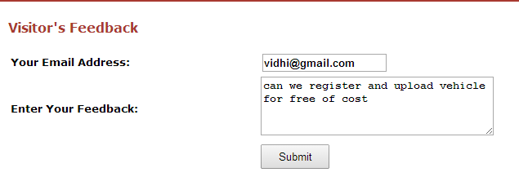

Figure Feedback given by Visitor

* 1. **Architecture design**



Figure Site Map showing the navigation within the system

* 1. **Design Decisions**

1. **Different master pages for Admin and Subscribers:**

**Reason:** As the functionalities of the Admin and subscribers are different, the master pages designed for them are different with their respective functionalities.

1. **Separate login interfaces for Admin, Free and Paid Subscribers**

**Reason:** There are separate login interfaces for Admin, free and paid subscriber according to the requirement specification given and the functions they are going to perform



1. **Color combination, font style and font size of master pages.**

**Reason:** Color combination selected is Maroon with white that improves readability of the web content and its clarity. Font used is normal 90%/1.8em 'Lucida Grande', Verdana, Geneva, Lucida, Helvetica, Arial, sans-serif for aesthetic purposes.

1. **Metaphors Used for functionalities**

**Reason:** There are several metaphors used in the system to match the real world entities with our system for its better understanding by the novice user.Some of the examples of the metaphors used are as follows:



**Car & (+) Icon:**

For Add or Upload Vehicle

**Home Icon:**

For subscriber homepage

**Exit Icon:**

For logout (exiting from account)

**Envelope Icon:**

For inbox with messages

**User & List Icon:**

For viewing list of all subscribers

**User & pencil Icon:**

For changing subscriber status

**User & cross Icon:**

For Deleting subscriber

**User & (+) Icon:**

For adding subscriber

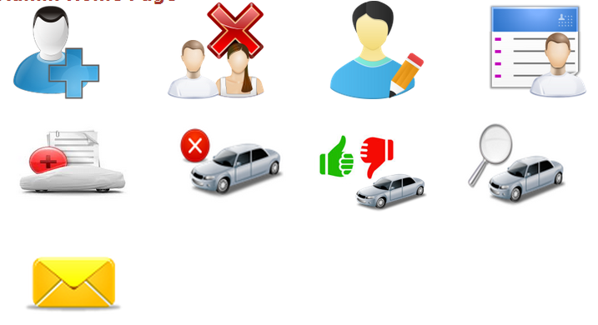

**Envelope Icon:**

For Sending Message

**Car & (+) Icon:**

For Adding Vehicle

**Car & cross Icon:**

For Deleting Vehicle

**Car & Magnifier Icon:**

For searching vehicle

**Car & thumb Icon:**

For Approving or Rejecting Vehicle

1. **Validations Used**

**Reason:** All the web forms are designed with proper validations wherever it was required. For example, the registration page is shown below with all possible validations:

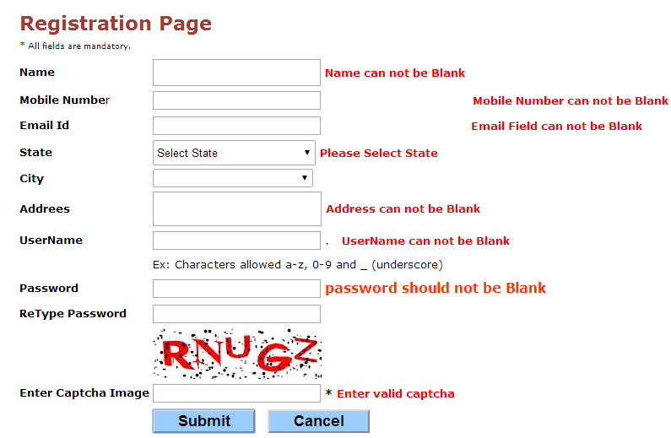

# Implementation

The implementation steps of the Online Web Portal of Sell and Purchase Used Vehicle are as follows:

First of all, research has been done. The developer has visited similar kind of designs to get the idea of what all contents should be present in the Sell and Purchase of Pre-owned Vehicle. Once the content has been decided, the web pages required for the system were developed in the following order:

1. **Master pages** are designed for Admin part and for Subscriber part. External **Cascading Style Sheet** was designed and linked to the master pages. Relevant Content pages are added to it.
2. **Designing** of all the content pages of Subscriber part like Registration, Add Vehicle, Search Vehicle, Check Inbox and of Admin Part like Add Subscriber, Add Vehicle, Search Vehicle, Send Message and linking the relevant pages together.
3. Registration Page was designed for the user of the website to get membership. This page includes personal details of the user. Besides username is asked for the username and password so that he is identified uniquely within the system and his information remains private. **Captcha** is used in Registration page to check whether human is performing registration or any agent.
4. **Database** is designed according the scenario with required fields and constraints. Table included in the database are for maintaining the information of Subscribers, information about the vehicles added by the subscribers, history of messages sent by Admin to subscribers, payment details of the paid subscribers and of feedback given by the visitors.
5. In vehicle details page, vehicle image has been uploaded. The vehicle image is stored into the database by converting it into binary format. During vehicle search by Admin and Subscriber, the vehicle image is retrieved with the help of **Image Handler** which converts the binary format image to image.
6. **Validations** are provided to the required controls on web forms so that only correct gets stored in the database.
7. **Forms Authentication**, one of the three types of the Authentication is implemented in this web portal by providing username and password to each registered subscriber and admin.
8. Two types of **Session variables** are used by the developer in this web portal. First session variable stores the username who has logged in and other one stores the type of user i.e. either free, paid or admin has logged in.
9. The developer has also implemented **Grid View** and **Custom Grid View with Check Boxes** and **Command Button** to perform functionalities of Admin such as Set Member Status and delete Subscriber.
10. **Check box list** is implemented to select multiple subscribers for sending messages by the Admin.
11. **Two Menus** are designed for free subscriber and paid subscriber and the required menu is loaded during page load according to the value of Session variable (‘Usertype’) whether it is free or paid.
12. **Personalisation** is implementedby giving users an option to select theme of their choice from the given list of themes.

# Conclusion

* 1. **Summary**

The developer has successfully completed the assignment of Enterprise Web Applications titled ‘Online Web Portal of Sell and Purchase of Used Vehicle’. It was a great learning experience. The web portal is developed in ASP.NET using C# and has backend database connectivity with the help of SQL SERVER. Developer has learnt the concept of page life cycle in Asp.Net and other concepts like Image handling, custom grid view, session variables, personalization and implemented one by one during the course of lectures.

The web portal developed consists of basically two important parts, Admin and Subscriber part. Admin has complete access on the whole system. Admin can add subscriber, delete subscriber, set subscriber status and view all subscribers. The vehicle information to be uploaded by the subscriber needs a confirmation by the Admin then only the vehicle is visible during search vehicle functionality. The subscriber has limited access to the system. Free and Paid subscriber can add vehicle, check messages sent by Admin and search vehicles. Paid subscriber can get the seller information during vehicle search but free subscriber not. Free Subscriber can send request to Admin with Payment details to get paid subscription. Visitor or anonymous user has very limited access to the web portal. He can only give feedback and register at the web portal to become registered user of the system. All the above mentioned functionalities are working in the system accurately.

* 1. **Future work**

The future work for this system would be as follows:

* Visitor should be given more access to use the system such as he can search vehicles as per his choice.
* The present system considers only the cities in India. It can be further extended to include other important cities across India.

# References

**Books:**

1. Chris Payne. (2002) *Asp.Net in 21 Days*. USA: Pearson Education
2. Wiley, J.(2002) Beginning *Asp.Net 3.5 in c# and VB.* USA: Pearson Education

**Websites:**

1. ASP.NET Tutorial. (2014).ASP.NET Tutorial. [ONLINE] Available at: http://www.w3schools.com/aspnet/default.asp. [Accessed 13 March 2014].
2. Working with Images: The Official Microsoft ASP.NET Site. (2014). *Working with Images: The Official Microsoft ASP.NET Site*. [ONLINE] Available at:<http://www.asp.net/web-pages/tutorials/files,-images,-and-media/9-working-with-images>. [Accessed 04 April 2014].

# 

# Appendices

1. **Gantt Chart**

